December 2012
Volume 1, Issue 1
Knights of Columbus Council 7408 Newsletter

Our Brother Knights came out in mass to serve over 500 students at the local MCC campus this past month.
Our Grand Knight led our Knights and if you look closely at the pictures you will see Jules proudly serving with our Council.
November surely marks us as a month of serving and preparing for the Christmas season!
Mass was held after the event.
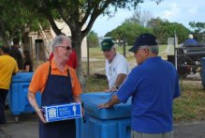
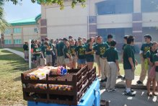
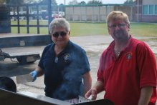

Pictures from Pat Farrelly

Special Interest Articles:

• Wishing you were there…what a great time we had at our Fall Festival at St. Joseph’s.

• So what about “Thanksgiving” 2012 more on page 8

• Grand Knight speaks out on “Helping us Grow”
Individual Highlights:
Fall Festival 1
Grand Knight 2
General Info 3
Fourth Degree 4
Ladies Aux 5
… 6

Newsletter Editor
Brian Volman
Email at briancgt@hotmail.com

Our festival this year started a week later but it did not damper our spirits with Thanksgiving looming a week away.
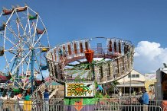
During the festival our Knights and Ladies served in many capacities. We cooked food and sometimes got to stand in a joyful manner, we parked cars, in fact lots of cars, played music for the people, had a chance to enjoy the festival and indulge in some of Fr. Bob’s outstanding clam chowders, his chili, the Moran’s corn dogs and French fries and the list goes on and on. Instead of boring you with words enjoy some of these pictures that we will put in the newsletter instead of making you go to the website to enjoy them.
My personal “thank you” goes out to all who helped and “joyfully served” this event. Without all of you serving it would not have been a success. Wasn’t the weather great for a fall festival?
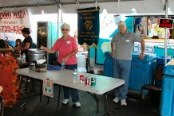

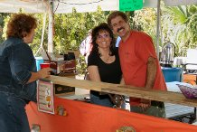
Photos by Robert Hoe
.

Fall Festival 2012…Joyfully Serving!

Still Serving at M.C.C….500!

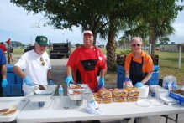

Grand Knights Corner

MY BROTHERS AND SISTERS ALL,
I would like to start off with wishing you all a HAPPY THANKSGIVING and to all your families as well. We started off the holiday season with three new members joining our ranks making their first degrees on NOVEMBER 9TH at our regular business meeting/1st degree exemplification which we started way back when BOB BURGESS was our GRAND KNIGHT and stopped in my first term as your GRAND KNIGHT. We decided to try it this way again to see how it will work and so far it has been working out smoothly and without too much resistance. We had stopped doing it in the meeting because of all the complaints of the meeting ending too late and some members were even leaving before the end of the meeting. I as your GRAND KNIGHT will always try and look out what is best for the good of the council and sometimes even then will get people who don’t agree, but as they say “YOU CAN PLEASE SOME OF THE PEOPLE SOME OF THE TIME BUT,YOU CAN’T PLEASE ALL OF THE PEOPLE ALL OF THE TIME.”
I have made some good decisions and not so good but all of the time trying to help this council and hall stay open. I and a few good men in this council started a breakfast at this council and I stopped it due to non-participation from members, sorry but I am done burning the candle at both ends and have to watch out for my health and welfare as well as the councils. I and a few good men started a spaghetti dinner as well and ended that when we were spending more money than making it and all the time still trying to do our best to keep these doors open.
We have a lot of things going on to keep the COLUMBUS CLUB financially set I hope for the future and that is the vegetable guy out in the parking lot and yes he pays rent and it goes to the C.C.I and BOB BURGESS met with a lady that is a ST. JOSEPH’S SCHOOL parent and wants to sell hot dogs outside in our front yard from MONDAY-THURSDAY and will pay us rent ,I talked to them at the festival and she will start on the Monday after THANKSGIVING (Nov.26th) .I also met with CHARLIE REIMAN and a lady from ST.LUKES who is starting a FARMERS MARKET (indoor flea market )on NOVEMBER 17TH and is starting off slow but we will be making some funds from that endeavor as well. I am mentioning this because I would like to let you all know that we have expenses and they will not get taken care of by themselves, it takes income to run a building and anything after that is money we can take care of our charities with and that is what we are supposed to be doing. I became a KNIGHT because I like to help people of my church and community and for a long time I was involved in ministries at ST. JOSEPH’S and really loved what I was doing. I was in PREP teaching faith formation to children who were in need of such church teachings and really miss doing that but I have moved on to the KNIGHT’S of COLUMBUS where we are giving back to our church and community in a different way. I was also involved in YOUTH MINISTRY which was a very rewarding yet demanding ministry as well. I look back now and wonder where I found the time for those time consuming and demanding ministries. I am only in one organization now and can’t seem to find the time for anything else. I love serving and helping others and I truly hope and pray that others in our council feel the same way as well.
I am asking for your help as we go into the holiday season and progress with the rest of our fiscal year, I have turned away a BROTHER and a friend to the point of him leaving the Friday night dinner which he started. I really do not want to get into how it happened and am very sorry for the way it turned out. We have lost a man who started the FRIDAY NIGHT FISH FRY some six years ago and who really put his heart and soul into this weekly event that is really right now and has been for many years a main source of the councils income. I cannot undo what I have done no matter what I have said, so I ask if anybody has kitchen experience and wishes to run this very important and much needed weekly event, please help your council out!!!!!!!!!I know that by now everyone knows who I am talking about and please do not blame anybody but me and if I can tell anybody anything about what happened I would tell them to their face and not in a text or an email that’s for sure!!!!!!!
I will continue to help out at this dinner as I always have tried to do in the past. Unfortunately I am not always able to make it at the times that BOB or JERRY MORRIS whom have been dedicated to this commitment and a few others will try to keep this going and again I am asking for anybody who is looking to help out their council on Friday night for a few hours or even if you can help out CHARLIE REIMAN who usually gets to the council on Friday mornings to set up for the cooks to come in later and not have to do as much. I am moving on and hope we can all and would like to thank BOB BURGESS for all those Fridays and for all the great things he has done behind the scenes and he knows what I mean. I know you will enjoy the break from having to come here every Friday and I truly believe we will keep up the good works and serve our faithful customers and any new ones as well, but please know that you will be missed.
We all had a great time at the FALL FESTIVAL at ST. JOSEPH’S and really would like to thank all our volunteers. We had many of our BROTHERS and SISTERS helping out in many different areas and booths; thank you everyone. I really hope and pray that we made some money for our parish so we can alleviate FR. BOB’S financial obligation’s or at least help diminish them just a bit. We have our annual Christmas tree lighting coming up and two parades; one on Dec.1st in Palm Bay and one on Dec.8th in Melbourne and I do believe we will be able to enter with the float and I would expect that we have many of our members of all ages to gear up and march or ride in one or both of these very beautiful parades, PLEASE!
I certainly hope that we all took advantage of the ICON of OUR LADY of GUADELUPE that we had displayed in the parish hall this year for the first time and you all had time to say prayers to her. I as your GRAND KNIGHT would also like to wish you all a very MERRY CHRISTMAS and ask that everyone think about others who don’t have all the luxuries and advantages that we do and maybe try and do something for another human being or a family and PAY IT FORWARD if you are able. LARRY SHORT and I had the honor of doing so from our council on Tuesday NOVEMBER 20TH when we purchased 12 turkeys and donated them to the HACIENDA GIRLS RANCH in the name of our council 7408.
VIVAT JESUS,
G.K. PATRICK FARRELLY COUNCIL 7408

YOUR ELECTED TRUSTED SERVANT



General Council Officers
2012-2013

Grand Knight Pat Farrelly
Deputy Grand Knight Lawrence Short
Chancellor Anthony Stoio
RecorderAnthony Krzeminski
Financial Secretary Mark Zarraonandia
Treasurer Michael McDermott
Advocate Walter Carper
Lecturer Edward Schmitt
Warden Mario Ramirez
Inside Guard John Pordon
Outside Guard Joseph Lembcke
3-Year Trustee Bob Burgess
2-Year Trustee Joe Moran
1-Year Trustee Tom Pernice

Council Information
Our Physical Location (for your GPS)
6725 Babcock St., Palm Bay, FL. 32907

Hall Phone Number
(321) 727-1722

We’re on the Web!!
See us at:
http://kofc7408.coffeecup.com/

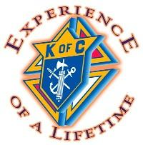

The Birthday Kids!

Alec Buchness, James Grossman, Clarence Kohnen, Anthony Krzeminski, Frank Mulligan, Reginald Potoczny, Timothy Riordan, William Stearly, Rev Michael Woodcock, Robert DeMair, John Reddy, Rita Kosack, Charo Hessen, MaryAnn Nola, Maria Titus, Rira Kim, Esther Parsley

Daniel P. Ahearn, Martin V. Armstrong, Walter Bartoszek, Michael Belgowan, Patrick Burke, Eugene M. Callagy, Richard Cullen, Paul Dick, Michael DiNapoli, Ed Duffy, John Engelhardt, Archibold (Archie) Gergen, William J. Kaye, Lloyd W.Lutz, Deacon Alan G. Michaels, John P. Monahan, Fr. Vincent J. Nebus, Oscar Felber, Samuel F. Puglise, Michael Quinn, Harold Snure Jr. and Clifford R. Wright.
Our sisters… Marjorie Fetes, Eleanor Debonis, Veronica Finn, Marie Rininstand, Alice Rozanski, Janet Schmitt, Eleanor Seifried, Elizabeth Terry, Evelyn Veronesi and Dorothy Zybala.
May they rest in peace and in the care of our Lord. Please pray for these brothers and sisters who have gone to their eternal reward.
Jesus said, "I am the Resurrection, and the Life; he that believeth in Me though he were dead, yet shall he live."



Remembering Our Brothers & Sisters
 Celebrating Their Anniversary!
Vincent & MaryAnn Nola, Alfred & Joan Dibartholomeo, Leonard & Carla Hill, Richard & Mary McCrea, Thomas & Herlinda Boland, Gerald & Melissa Lague, Gerald & Mary Mursko, David & Lanora Mancini, Bernard & Gerry Seman, Thomas & Marjorie Smith, Tim & Gigi Chasey

Meetings
(all meetings are at the Council Hall unless otherwise announced)

Fourth Degree First Thursday at 7:30 PM
General Council Second Thursday at 7:30 PM
Columbus Club Second Thursday at 6:30 PM
Social Meeting Fourth Thursday at 7:30 PM

First Degree Third Thursday at 6:30PM
(When Announced by G.K.)

Newsletter Deadlines (Space Available and First Come) 4th Thursday of Every Month.

Dinner Reservations??

Come Join Us For Dinner On Friday Nights. Dinner begins at 5PM until 8PM
We serve some of the best food in town with some of the best prices!
We’re located at; 6725 Babcock St., Palm Bay, FL 32907
Hall Phone Number: 727-1722

It’s MORE than just fish!!


If you only click on one link this month…THIS IS THE ONE!!

http://www.youtube.com/watch_popup?v=D9vQt6IXXaM&hd
If you care about your country…start clicking!!
The True Meaning of Marriage

In a Time Magazine article, Caitlin Flanagan observes that, while the divorce culture has become a fact of life over the past twenty-five years, the middle class has turned weddings into “overwrought exercises in consumer spending, as if by just plunking down enough cash for the flower girls’ dresses and tissue-lined envelopes for the RSVP cards, we can somehow improve our chance of going the distance.”

In our culture, marriage means less, but we spend more on our weddings. Go figure.

Flanagan concludes with these ominous words about the future of our country: “What we teach about the true meaning of marriage will determine a great deal about our fate.”

Scott Grant, The Way of the Lord in Marriage

Dear Sir Knights,
I certainly hope everyone had a Happy Thanksgiving. We all have so much for which to be thankful, even if the election did not turn out as we had wished. We must just pray harder in the coming weeks.
Christmas is fast approaching and unfortunately many in our society wish to take the real meaning of Christmas out of our lives and replace it with some commercial interest. To me Christmas will always be going to the woods cutting a tree, bringing it home, and decorating it with colored paper chains that we made ourselves. You see, we had no electricity for colored lights and even if we did have electricity, during the depression, there was no money for such material things. I can remember a couple of Christmas mornings nothing under the tree. Other times there would be a pair of socks but we did have our faith in God. We never failed to attend Midnight Mass at the little St. Joseph Church on Miller Street. Before I get teary eyed, best I let you know some of the happenings in the Assembly.
This past week I received a call from Fr. Doug's office at FIT advising that the Bishop would be here the 7th of December to dedicate the dorms that will be built on the campus of Melbourne Central Catholic to accommodate Catholic students attending FIT. You may remember last year Ken Madder and I financed a spaghetti dinner at the Council Hall, the proceeds to kick off the fund raising for this project. Our Honor Guard has been asked to attend and of course we will be there.
Speaking of the Color Corps, since Tom Pernice and his wife are experiencing health problems, I have decided to make Tom Boland the Commander and Tom Pernice the Co- Commander. Tom Pernice has done a superb job but it is unfair to ask him to continue with the health problems he and his wife are undergoing.
January the 13th we will renew our Obligations at the Council Hall so plan to be present.
In February we have the Valentines Dinner/Dance and it is not too early to be making necessary arrangements. We will discuss both of the items more in detail at the regular meeting on the 6th of December.
Have a blessed Christmas and may the Good Lord bless and keep you,
Ed Schmitt,
Faithful Navigator

Sir Knights of the Fourth Degree



Fourth Degree Officers

Faithful NavigatorS.K. Ed Schmitt
CaptainS.K. Frank Sapienza
PilotS.K. Bob Allaire
AdmiralS.K. Paul Gallant
PurserS.K. Kevin Roberts
ComptrollerS.K. Mario Ramirez
ScribeS.K. Robert Karl
Inside SentinelS.K. Jose Santana
Outside SentinelS.K. Larry Short
Trustee 1 YearS.K. Frank Ferrante
Trustee 2 YearS.K. Tom Pernice
Trustee 3 YearS.K. Cy Remillard
“

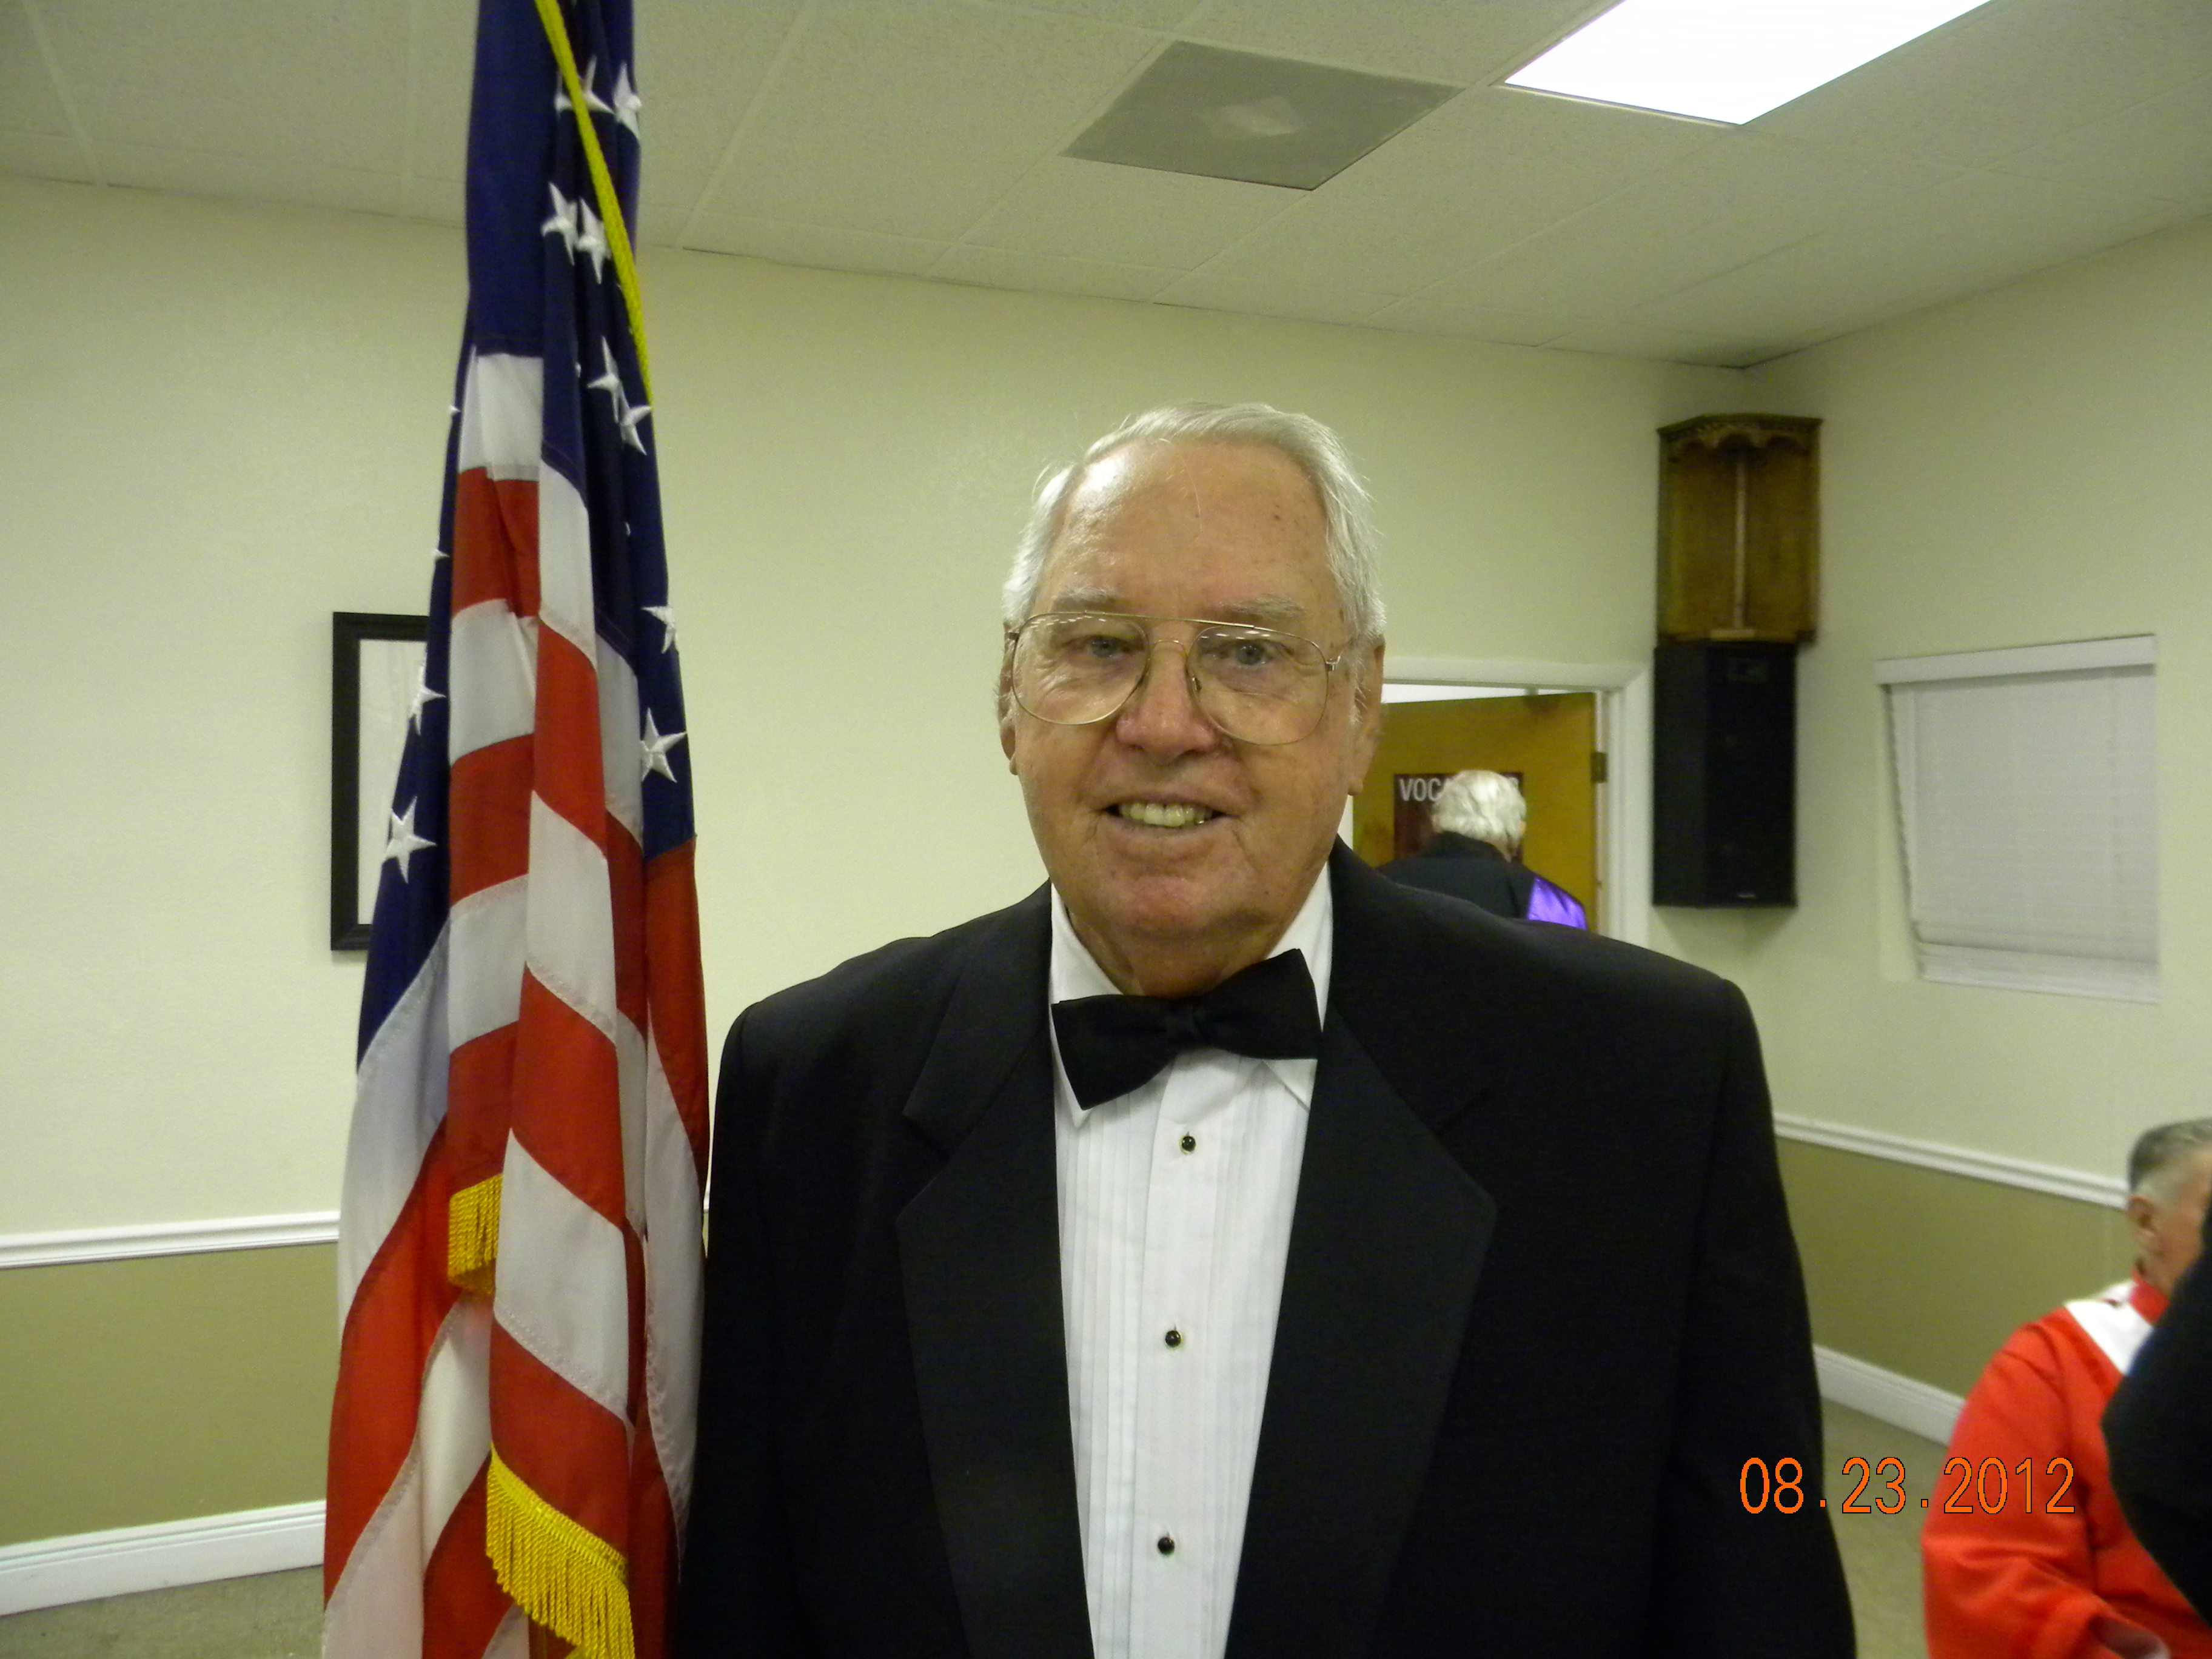

Knights of Columbus
Fourth Degree
Pope Paul Assembly 76
CHARITY, UNITY, FRATERNITY, AND PATRIOTISM
Currently Meets at St. Joseph’s Council 7408 Hall, 1st Thursday of Every Month at 7:30 PM
Fraternal Services SK Bob Karl
Email: rkarlsr@bellsouth.net, Home Phone: 321-956-5652 Cell Phone: 321-591-7833
At each council meeting we have K of C wearing apparel and emblems for sale at a profit. We have a limited inventory of Gulf shirts, T-Shirts and no hats at this time. We have auto emblems, decals and license plate holders. I have used the proceeds from previous sales to order additional golf type shirts. This will provide more verity of sizes of red, blue and white shirts. I have also ordered some blue 4th degree shirts in a verity of sizes.
Next we will provide hats if there is an interest.
One Sunday in early July I met one of our more popular brothers coming out of the 9:45 mass. He was wearing his K of C shirt. When I greeted him, I said what great advertising and he agreed.
It would be a great way of “Getting The Word Out” if we would all, randomly, wear our shirts to Mass. The one problem with wearing our shirts to mass is you can’t do it if you don’t have a shirt. Come see me I can help you with this problem.
.

Fraternal Services

Remember as Thomas Jefferson wrote:"We in America do not have government by the majority---we have government by the majority who participate ---All tyranny needs to gain a foothold is for people of good conscience to remain silent."

CRHP
A Day of Reflection

Coming: Feb 23, 2013

Where: Our Council Hall

More info in our January newsletter. Keep this date open!

Triva: Team Nine was our last team. What was the month and year of that team?
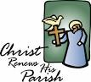

Ladies Auxiliary

Officers 2012-2013

President Gloria Ferrante
729-6982
Vice President Nancy Santos
Secretary Susan Burgess
Treasurer Lucy Pernice
Sergeant at Arms Patty Kern

Trustees
2-Year Trustee Shirley Uhall
1-Year Trustee Marie Rinando

Auxiliary Committees
Chaplain Pat Adamo
Bereavement Gloria Ferrante
Sue Burgess
Publicity OPEN
Hospitality Pat Adamo
Decorating Marie Rinando
Gloria Ferrante
Membership Patti Kern
Sunshine Wilda Karl

Children’s Outreach Gloria Ferrante

Telephone & 50/50 Lucy Pernice
Dear Ladies,
First of all a reminder to all that our Christmas Party/Tree Lighting will be on Tuesday December 4th at 6pm. More information follows this letter and hopefully many will attend.
I am so happy to tell you that we had 22 ladies attend our Tuesday morning meeting on November 13th. We had an informative meeting and then a lovely turkey luncheon. Shirley Uhall made a most delicious vegetable salad. Everyone was asking for the recipe so we’re including it in this newsletter.
We presented St. Vincent de Paul with a $100 check to help for the Thanksgiving holiday. They were most appreciative. We start this month for the planning of our only Fund Raiser of the year, our Fashion Show, to be held on Saturday, January 26th at 12 noon. I will have tickets at our Christmas Party. Susan Burgess and her daughter, Robin, have once again agreed to cater our luncheon. They always do a wonderful job. We are increasing the price of the ticket two dollars to $12 instead of $10. Please attend and try to sell as many tickets as you can. I would also like to ask you to consider donating gifts for our sweepstake prizes valued at $10 and over and also for our door prizes valued between $3 to $5. Please remember that this is always a successful event because so many of us work at this and make it a whole team spirit.
Being we are having our Christmas luncheon at the Shack on Tuesday December 18th, I am asking that those of you who wish to donate a gift to the Children’s Home Society in Melbourne, as we did last year, please bring a gift to our Christmas Party on December 4th. Last year they were so appreciative of the gifts we brought. This way I can bring the gifts to them before I go on my cruise on December 9th.
Frank and I want to wish you all a Blessed Christmas and a Happy and Healthy New Year.
God Bless,
Gloria

Recipe is on page 8.

Vatican Gift Rosaries
Finest handmade Rosaries
selection Blessing by Benedict XVI
on request www.vaticangift.com

FASHION SHOW BEGINS AT 12 Noon

“Heads Up”
Christmas Party & Tree Lighting Ceremony
Tuesday December 4th, 2012, 6pm

Pot luck dinner will follow. Knights will provide Ham. Please bring side dishes and desserts.

Sing a long by Msgr. Cleo, Mickey and the “Singing Nun”. The tree will be lit exactly at 8 pm. The time that all the Councils thru out the world light their trees. Please attend this special night with us. Children are welcome.
Call Gloria for more information at 729-6982.

Upcoming Events!

Knights of Columbus

Council 7408
Some Christmas thoughts and since I work for a very major on line retailer this particular article comes with very current observations and the value’s I grew up went where???

Jesus came to save humans from being rat packs feeding on each other instead of sheep feeding with each other. This was never made so clear than in the recent "Black Friday" images of people stomping on each other and fighting it out, all done to the musical background of Christmas music.

Our sentimental - yet always cynical - culture likes to start singing Christmas carols the moment Thanksgiving turkeys come out of the oven. But listen carefully: You're hearing a lot more choruses of "Jingle Bells" and "We Wish You A Merry Christmas" than carols like "Hark the Herald Angels Sing" or "O Little Town of Bethlehem." The world wants, the world needs, to celebrate Christmas. But the world does its best to keep Jesus out of it.

Perhaps the first "Christmas carol" Christians should sing, in keeping with the theme of "Advent," is the Willie Nelson special "On the Road Again." As stores keep having cut-rate sales and on-line deals; and as holiday partying, parades, and posturing swamp every level of our lives: it is good to stand back and look at the bigger picture. What is the purpose for which Jesus came into this world in the first place?

Let's get "on the road again" with the first journey to Bethlehem and the reason that journey was taken...
Let’s “Keep Christ in Christmas”.


This is the actual picture of the icon taken by Robert Hoe when it ws displayed in our church.

Our Lady of Guadalupe Prayer Service

Thispast month the Saint Josephs Knights of Columbus Council is proud to be able to share with our pariosoners an icon of Our Lady of Guadalupe which has traveled with the Knights of Columbus on a pilgrimage throughout the country, bearing her image from council to council and from parish to parish to spread her message and her love.

The image of Our Lady of Guadalupe was blessed by His Holiness Pope Benedict XVI and was also touched to the original image of Holy Mary of Guadalupe on St. Juan Diego’s tilma, when Supreme Knight Carl Anderson and Supreme Secretary Emilio Moure traveled to Mexico City. Each image bears the signature of the Rector of the Basilica of Our Lady of Guadalupe and was sealed with a bit of soil from the first Church at Tepeyac Hill – the very terrain on which Our Lady appeared to St. Juan Diego almost 480 years ago. St. Juan-Diego was a humble layman, chosen by God to be the bearer of Our Lady’s image and message. Nearly 500 years later, we the Knights of Columbus, Saint Josephs Council #7408 are called, like St. Juan-Diego, to be heralds of the New Evangelization, carrying Our Lady’s beautiful image and message of love.

Please join us to learn more about Our Lady of Guadalupe, Mother of the Americas, as we ask Our Lady to intercede for us with our prayers and special intentions.Vivat Jesus!



Editors Take on Christmas…

6725 Babcock St.
Palm Bay, FL 32906

Phone:
(321) 727-1722

We’re on the Web!!
See us at:
http://kofc7408.coffeecup.com/
E-Mail:
Kofc7408@hotmail.com

Book Your Next Party With the Knights!!
Prices begin as low as $75
Knights receive special discount packages
Call
Tom Pernice at 574-5312
Or
Ed Kosack at 676-7008, Ed’s cell phone
537-9088

No party is too small and we can seat over 100 people in our newly remodeled Main hall.

Save even more with our combo
package when you use our DJ and rent our hall.

Knights of Columbus
St. Joseph Council 7408
P.O. Box 060778
Palm Bay, FL 32906
Hall Phone 321-727-1722
(Send payments to this address)

Rent our hall…prices begin as low as $75.00. Call Tom Pernice at 574-5312 OR Ed Kosack at 676-7008. Ed’s cell phone number; 537-9088.

Knights in “good” standing…get discounts!!
Find us on the web at:
http://kofc7408.coffeecup.com/

E-Mail Inquiries To:
Kofc7408@hotmail.com

Calendar of Upcoming Events

December

01 Palm Bay Christmas Parade
02 Pancake Bkfst at St. Joseph’s
First Day of Advent
04 KofC Tree Lighting/Potluck
06 Fourth Degree Meeting 7:30PM
07 Pearl Harbor Day
13 Columbus Club Meeting 6:30PM
General Council Mtg. 7:30PM
20 First Degree (Tentative)
21 Winter Solstice
25 CHRISTMAS DAY!
Happy Birthday Jesus!!
27 No Social Meeting
30 Holy Family of Jesus
31 New Years Eve
Official End of W.W. II

January 2013

01 New Years Day
03 Fourth Degree Meeting 7:30PM
06 Epiphany
10 Columbus Club Meeting 6:30PM
General Council Mtg. 7:30PM
13 Feast of the Baptism of Christ
Fourth Degree Renewal 3PM
17 First Degree (Tentative)
21 M.L.K. Birthday
24 Social Meeting 7:30PM
26 Past Grand Knight, Faithful
Navigator, Ladies Aux Recognition
Principles of the Order 3PM at Fr.
Gabriel Council Hall

February 2013

02 Ladies Aux. Fashion Show
Ground Hog Day
03 St. Blaise Blessing
Super Bowl Sunday!
07 Fourth Degree Meeting 7:30PM
10 Transfiguration Sunday
Chinese New Year
12 Lincoln’s Birthday
13 ASH WEDNESDAY
14 Valentine’s Day
Columbus Club Meeting 6:30PM
General Council Mtg. 7:30PM
18 President’s Day
21 First Degree (Tentative)
22 Washington’s Birthday
28 Social Meeting 7:30PM

Recruiting
Welcome to our three new brothers who made their First Degree at the last business meeting Nov. 8th. Patrick Lynch, Stephen Malinowski, and Daniel Lee.
It is the responsibility of every member to bring new members into the council. We are 12 members short of attaining our "Star Council" goal of 18 new members this council year. Please make an effort to promote the Knights of Columbus and St. Joseph's Council when speaking to parishioners before and after Mass. Help our council grow and meet its goals.
Larry Davis

Lt. Col. Phil & Joan Borsiks
Lorraine Callagy in memory of Gene Callagy
Patrick & Mary Farrelly
Frank & Gloria Ferrante
Henry Gartner
Karl & Patty Kern
Ed Kosach
D.D. Jules & Nancy Moquin
Joe Moran
Gerald Morris
Sam Oliver
Phil & Lena Rosaci
Larry & Jennifer Short
FDD/PGK William & Lois Stearly
Mike & Shirley Uhall

It’s never too late to become a Booster. Its just $5 per name.
Boosters are due…please remit payment to the Treasurer, Mark Zarraonandia (zarra@mindspring.com) Lets make this scroll a whole page!!

KofC Boosters Club…


OUR JOB…to keep “Christ” in Christmas…Merry Christmas!!
The Teddy Bear Squad
During the month of January, our council and St. Joseph’s School are teaming up to collect Teddy Bears to donate to the Palm Bay Police Dept. The bears will be used by police officers responding to incidents where young children are involved, e.g. accidents, lost children, disturbances, etc.

The bears give children something to hang on to and serve as a means to alleviate fear and apprehensions. The bears also show the police officers as their friends and not someone to be afraid of.

We are asking council members and parishioners to help in one of the following ways:

1. Purchase a Teddy Bear ( must be between 8in. & 16in.) from your favorite toy store and donate it to the program.

2. Donate money for us to purchase of a Teddy Bear.

3. Make a Teddy Bear of your choice at “The Bear Factory” store in the Melbourne Square Mall. The Bear Factory is reducing their 8in bears from $10.00 to $5.00 and their 16in bears from $18.00 to $10.00. They are also discounting clothing for the bears and offering a fully dressed (clothing of your choice) 16in bear for $19.95 exclusively for this event.
St. Joseph’s School students will participate on a specific evening ( date yet to be determined) at the Bear Factory where they will be able to make Teddy Bears and fill a PBPD squad car.
We will also have the squad car available after all Masses one weekend toward the end of January.

Our goal is to collect a minimum of 200 bears and we are asking council members to assist in the event.

The Recipe…
Marinated Vegetable Salad

Drain

2 cans French green beans
2 cans Carrots (Julienne)
1 can Leseur peas
4 oz Pimento (Chopped)

Chop

1 cup celery
1 cup bell pepper
1 onion (chopped)

Boil & pour over vegetables

½ cup vegetable oil
2 cups sugar
1 cup vinegar
1 tsp. salt

This will keep up to 5 weeks
in the refrigerator.

Enjoy!!

Remove Dryer Lint
Prevent Fires by Removing Dryer Lint
Every year, nearly 25,000 dryer fires cause millions of dollars in damage and hundreds of injuries, some fatal. Dryer fires start when built-up lint near the motor, gas burners or heating elements catches on fire. This fire can then spread to ignite lint in the vent pipe. Learn how to get at built up lent and the best way to clean it out.

Get the lint out
Every year, nearly 25,000 dryer fires cause millions of dollars in damage and hundreds of injuries, some fatal. Dryer fires start when built-up lint near the motor, gas burners or heating elements catches on fire. This fire can then spread to ignite lint in the vent pipe.
The best precautions are to empty the lint trap after every load, vacuum behind the machine regularly, keep flammables away from the dryer, and annually clean lint from inside the dryer cabinet and vent duct.
We show how to “de-lint” a gas dryer with a front access panel. Electric dryers have a heating element instead of a gas burner. If you have an electric dryer, or your dryer differs from the one shown, consult your manual for instructions on accessing the heating element or cabinet interior.
The most important step in cleaning the dryer is to remove any lint buildup around the motor and gas burner or heating element. Then clean out the vent duct with a 4-in. dryer vent cleaning brush (sold at appliance repair stores, or online).
If your dryer has a plastic vent ducting, replace it with a metal one. The plastic ducting itself can catch on fire and set the house ablaze.

Unplug and disconnect

Dryer vent brush

Finding the Lint Traps
- Unplug the machine and turn off the gas valve. Pry the access panel loose with a big flat-blade screwdriver. Vacuum the inside of the cabinet, especially around the gas burner and motor. If you have a brush attachment for your vacuum, use it to loosen built-up lint.
- Disconnect the vent from the dryer and push a vent cleaning brush through the exterior vent hood. Otherwise, disassemble the vent and clean it by hand.

Caution!
Unplug the dryer and shut off The gas valve before pulling it out to clean. If you smell gas after turning the gas valve back on, immediately turn it off and call your local gas utility.

Reprinted from the “Family Handyman”
Click on the blue hyperlink words for more helps from this website. Of course you must be reading this on your computer in order to do so.

I just cleaned my dryer and vent which has pretty much been neglected for 16 years. I picked up the dryer vent brush at a local store for around $20 and feel a lot safer with my dryer now. You would not believe the amount of dryer lint that builds up in your vent!

I can now speak from experience…merely sticking your vacuum hose up the dryer vent does NOT clean it out.

Holiday Desserts that Are Diet-Friendly

←→
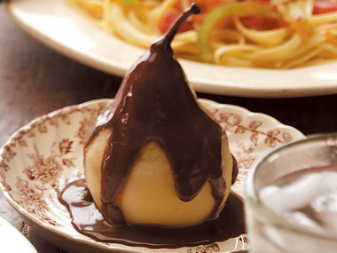

Poached Chocolate Pears
A gorgeous baked pear turns into dessert when you pour this creamy chocolate sauce—with its hints of cinnamon, vanilla, and nutmeg—on top.
Fat releasers: pears, cinnamon, nutmeg, cocoa, milk
Get the recipe at Taste of Home
And more …….from Readers Digest.

I hope everyone has a very Merry and Blessed Christmas and most Happy and Prosperous New Year in 2013.

Merry Christmas everyone!

